PRESS RELEASE
No. 147/SP/TKP-ASEAN2023/8/2023
PUBLIC COMMUNICATIONS TEAM

FOR IMMEDIATE RELEASE

AIPF Focuses on Strengthening Cooperation in Crucial Sectors

Padang, Kominfo Newsroom – ASEAN Indo Pacific Forum (AIPF) which will be held on 5-6 September 2023 will focus on strengthening cooperation in sectors that are crucial for the future of ASEAN.
This was stated by Indonesian Foreign Minister Retno Marsudi through a virtual connection at a public lecture entitled "The Role of the Ministry of Foreign Affairs in the Implementation of Indonesian Soft Power Diplomacy" held at Andalas University, Padang, Monday, 21 August 2023.
"For example, green infrastructure, strategic industrial supply chains, digital transformation, and the creative economy," said Retno Marsudi.
Through this concrete and inclusive cooperation, she said, the cooperation and trust in the Indo-Pacific region will always be maintained. AIPF itself is part of the 2023 ASEAN Summit series which will be held in Jakarta.
Retno said that referring to the foreign policy constitutional mandate, Indonesia must and will always contribute to world peace. This is in line with the theme of Indonesia’s 78th Independence Day Anniversary Commemoration " Moving Forward for Advanced Indonesia". Indonesia will continue to play a positive role for the world, the Indo-Pacific region, including in Indonesia's Chairmanship in ASEAN.
Indonesia's foreign policy efforts also need to get support from all levels of society in the country. Therefore, Retno invited all parties to continue to strengthen their commitment to advancing Indonesia.
On this occasion, Retno Marsudi again mentioned three main focuses that Indonesia would implement during the 2023 ASEAN Summit.
"First, we want to lay a strong foundation for the vision of ASEAN 2045," she said.

Amid the global turmoil, ASEAN must have the capacity to face future challenges. The organization must be able to make decisions in emergency situations.
Therefore, the ASEAN Concord is planned to be decided as the foundation for the organization's long-term vision for 2045. This foundation will continue to be built during Indonesia's Chairmanship in ASEAN.
The second point, Indonesia wants to strengthen Southeast Asia as the epicenter of economic growth. This is considering that ASEAN has strong capital with a population of more than 650 million people, economic growth that is always above the global average, and the Southeast Asian region is relatively peaceful and stable.
Moreover, the Organization for Economic Co-operation and Development (OECD) considers Southeast Asia as one of the drivers of world economic growth.
ASEAN has also been rated by the OECD as the region with the best economic opportunities. Not only that, referring to a survey conducted by the EU-ASEAN Business Sentiment which was released on 1 August 2023, the European Union's trust in ASEAN is still very high.
"We must continue to maintain this positive situation. In order to become a center of economic growth, ASEAN must be more resilient in facing future challenges," said Retno.
Through the 2023 ASEAN Summit, Indonesia is determined to maintain the resilience of ASEAN Member States in the fields of food, energy, health, climate change, finance, including human resource capacity.
The Third focus, said Retno, Indonesia's priority during its chairmanship in ASEAN is to encourage the implementation of the ASEAN Outlook on Indo-Pacific (AOIP) or ASEAN's views on the Indo-Pacific.
Over the last five decades, ASEAN has built an inclusive regional architecture, and ASEAN has emerged as a leader in terms of stability, peace and prosperity in the Indo-Pacific region.
"In the midst of increasingly sharp rivalries, Indonesia continues to push for concrete and inclusive cooperation with all ASEAN partners," she said. (M. Zulfikar/TR)
***
For more information, please contact:
Director General of Public Information and Communications of the Ministry of Communications and Informatics – Usman Kansong (0816785320).
Get more information at http://infopublik.id.

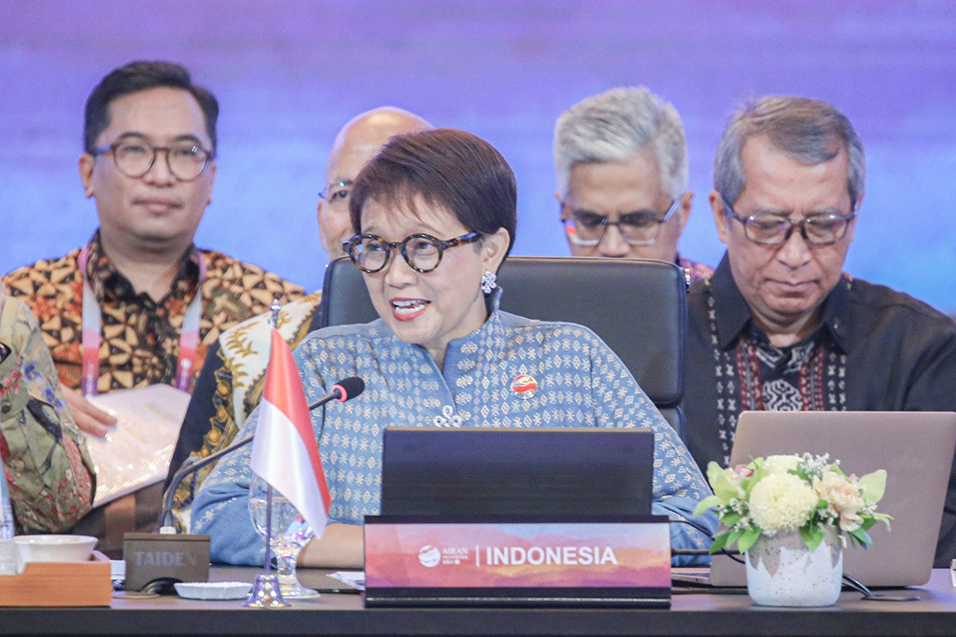

Indonesian Foreign Minister Retno Marsudi emphasized that the ASEAN Indo Pacific Forum (AIPF) which will take place on 5-6 September 2023 focuses on strengthening cooperation in sectors that are crucial for the future of ASEAN. (Photo: illustrasi/Infopublik)

